Petek, 27. 3. 2020
1) UČ 51/1
- Compete the sentences. Find them in the text CHEAT! (Dopolni povedi. Poišči jih v besedilu Cheat!)
- Write title: HAVE TO / DON’T HAVE TO in your notebook. (V zvezek napiši naslov.)
- Copy the picture and the sentence below into your notebook (Spodnjo sliko in stavke pod njo prepiši v zvezek):
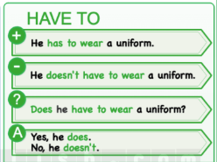
We use HAVE TO to express an obligation. We use DON’T HAVE TO when there is no obligation.
(HAVE TO uporabljamo za izražanje obveze. DON’T HAVE TO uporabljamo za izražanje, kadar nekaj ni obvezujoče.)

2) UČ 51/2
- Order the words to make questions (answers below).

3) UČ 51/3
- Listen to an interview (17 Track 17) with Laura. Tick ( ) the things she has to do. Then write sentences with HAVE TO and DON’T HAVE TO (answers below).

4) UČ 51/4
- Look at the words in the boxes. Write what they HAVE TO do and what they DON’T HAVE TO do.
SEND OR UPLOAD A PHOTO OF YOUR NOTEBOOK!
Naložiš lahko sem: https://1drv.ms/u/s!Aj9Ph4QLjmDYhGjkkPRBiTPmX5ox?e=KuzN6f
Navodila za nalaganje datotek v OneDrive sem vam poslala včeraj zvečer. V kolikor ti to ne gre, pošlji po e-mailu.

5) Work online
https://www.englisch-hilfen.de/en/exercises/tenses/do_not_have_to.htm

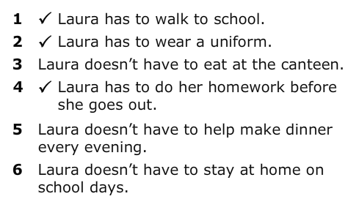
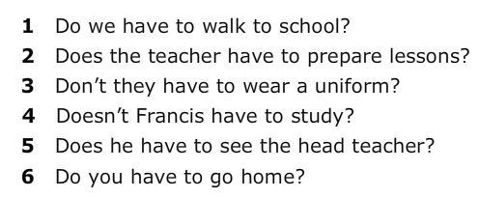
Answers (rešitve):
2) 3)

